On this day in 1915 the 4th and 5th Bns as part of 155 Bde of the 52(Lowland) Division were to attack three Turkish trenches and halt at the third trench. The 4th would lead with the 5th in support. The attack would be preceded with a barrage to soften the enemy up.

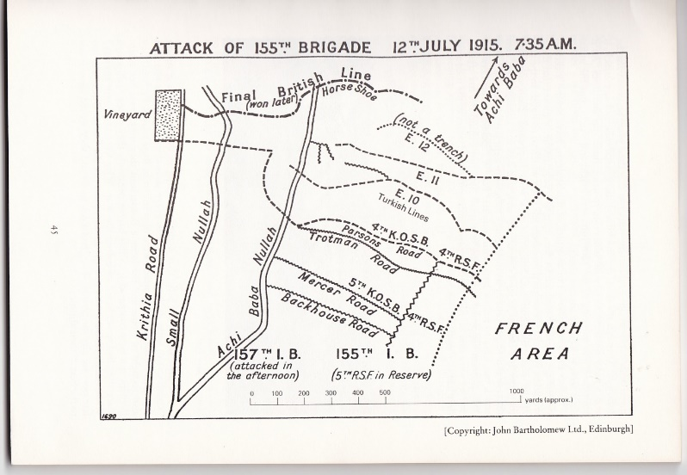

The Borderers rehearsed the attack in the previous days, Royal Engineer teams would accompany them to repair trenches for occupation and lay communication wire.

At 0735 the largest Artillery bombardment of the campaign increased its range allowing the Borderers of the 4th to go over the top to cries of “Scotland forever”. The Charge had begun. Even through devastating fire the Turkish guns replied and the Border lads felt the force of enemy guns and suffered casualties as they waited.

Orders were to cover the ground quickly no firing bayonet only, the first trench around 50 meters away was reached quickly any surviving Turks were bayoneted as the Jocks stormed past. The second trench was reached and the Turks were given more Border steel, by now Turkish Machine guns were creating many casualties within the Borderers ranks.

The third trench turned out to not be a trench, this caused confusion, some men tried to build a parapet while others continued forward. Sadly this eagerness to advance pushed the Borderers into the impact area of our own guns.

The CO Lt Col J McNeile realised the seriousness of the situation being in the forward group he could see what was happening, after consulting with the Adjt Capt Lang the order was given for the Bn to retire to the second trench. As they turned the shiny discs on the backs of some men which were being used to assist the Artillery spotters now shone towards the Turks who increased their fire on the Borderers in the open. The British guns on seeing the advance of troops thought it was a Turkish attack, the French guns on the right flank also believed it to be a Turkish attack. The Borderers were now under fire from all sides and they fell like harvested corn.

The Borderers would remain and fight for two days until relieved on the morning of 14 July, they would regroup and attempt to recover their dead and move to the rear.

Many acts of gallantry would be displayed over those days, every town or village in the Borders would suffer pain and loss. The Borderers fought with great courage, they advanced as one and never faltered, they achieved their objective only the fog of war was their undoing.

The cost was high from the 4th:

OFFICERS KIA 12 Including the CO whose body was never found

OFFICERS WIA 6

ORs KIA 319

ORs WIA 203

From the 5th:

OFFICERS KIA 6

OFFICERS WIA 5

ORs KIA 76

ORs WIA 183

ONCE A BORDERER ALWAYS A BORDERER