MEMORIAL SWIM 16 APRIL 2024

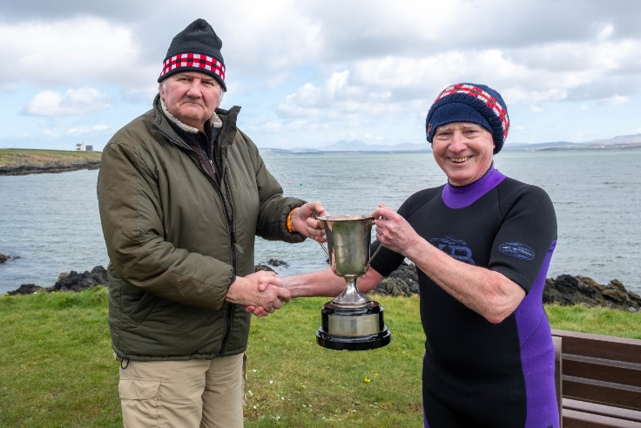
Russell Combe presents the John Pullman cup to Paul Middlemiss
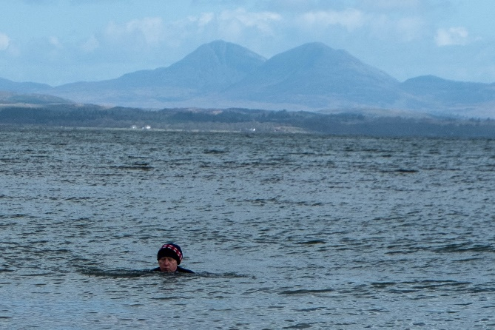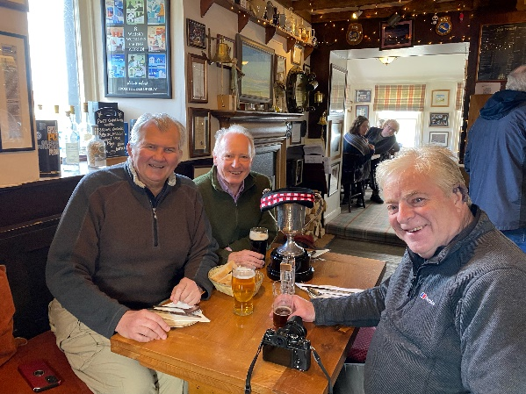
Paul in the water Russell, Paul and Peter Aitken take the cup for a drink
' Paul Middlemiss, Russell Combe and Peter Aitken met up again this year for the annual KOSB Memorial swim. Last year at Scourie, it was to remember Clive Fairweather; this year, to celebrate the life of John Pullman. The swimming event was held at Port Charlotte on 16th April and was won by Paul Middlemiss, successfully defending his title (Paps of Jura in the distance).
And being on Islay, those 10 distilleries (or was it 11?) had to be visited with all those 'welcome drams!'
A fuller account will appear in the next Borderers' Chronicle.'

